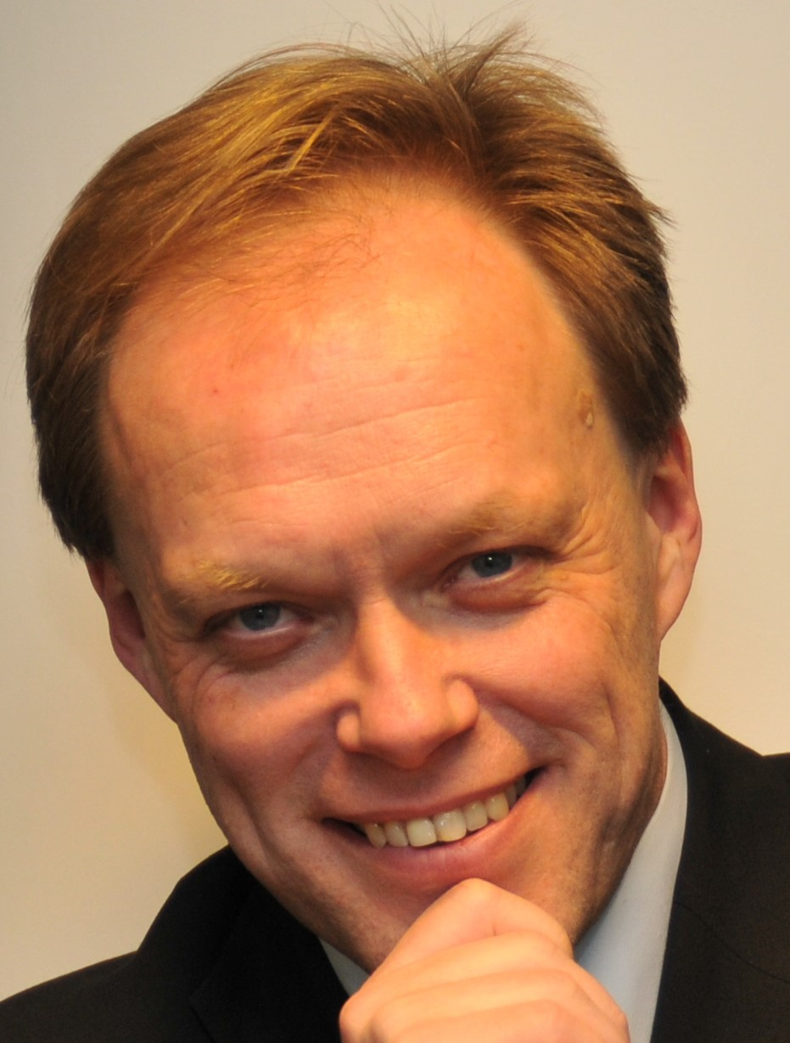

Kurt Vandenberghe

Kurt is Director for Policy Development and Coordination at the European Commission's DG Research and Innovation since 1st February 2016.

Before that, he was Director for 'Climate action and resource efficiency' at DG Research and Innovation since July 2013.

He served in the Cabinet of Research Commissioner Philippe Busquin (1999-2004) and as Head of the Cabinet of Janez Potocnik, who was Commissioner for Research and Innovation (2004-2009) and subsequently for Environment (from 2010).

Kurt joined the European Commission in 1996 as co-ordinator of the Commission’s Intermodal Transport Task Force and of the Transport Research Programme.

Before entering the Commission, Kurt worked for 4 years as a manager at Ernst & Young Association Management, where he set up, managed and represented international trade associations.

After reading French and Italian literature at the Katholieke Universiteit Leuven (KUL) and obtaining a degree in Public and International Affairs at the University Catholique de Louvain-la-Neuve (UCL), Kurt gained a Master of Arts degree in International Relations at the Johns Hopkins University School of Advanced International Studies (S.A.I.S.) in Bologna, Italy and Washington D.C., US.

Kurt is co-founder and board member of Journalismfund.eu and the VZW Scriptieprijs.

