Damsin Fabienne Application mail
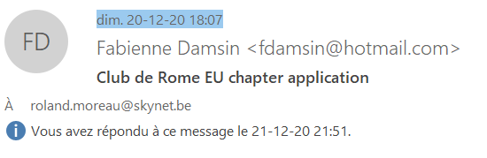
Dear Roland,
My years working for humanitarian and environmental organizations forged my decision to apply for the Club de Rome - EU chapter.
Since decades, even centuries, our relationship with our environment has been shaped by the "nature versus culture" paradigm and the objectification of nature. This dichotomy entwined with an economic system where wealth is more important than well being brings us near the limit of our planet capacities. Putting the environmental system under pressure as we do since decades not only degrades nature, but has generated an increasing number of famines, conflicts and human migrations. And this will not positively evolve in the coming years. Not to mention the rapidity of these changes and the level of emergency we are in.
I profoundly believe that it's by acting to influence society changes, participating in civil society movement, business evolution and policies changes, that we can succeed to fight against a treat that put our societies and nature at risk.
If we want to secure our future, we need to transform our economic system rapidly.
For these reasons I want to invest time and energy in a change-making organization, to be part of this change, as much as I can.
In conclusion, I think that my particular academic and professional background make me a valuable asset for your organization.
Thank you so much for your time and consideration.
Best Regards
Fabienne Damsin

